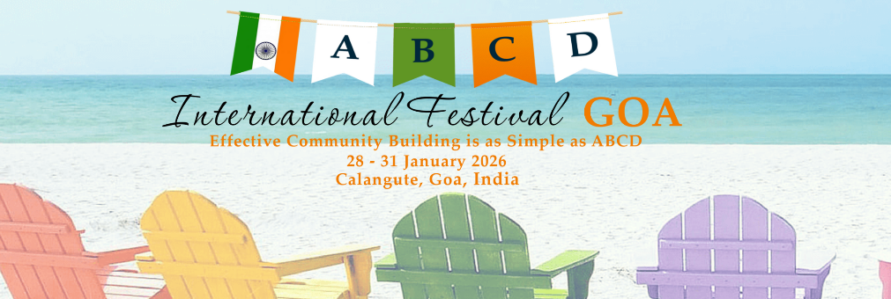

International ABCD Festival Goa
28-31 January 2026
Calangute, Goa, India

Effective Community Building is as Simple as ABCD!

Presenter Application Form
Please fill in all the details below. Please note, the International ABCD Festival Goa is being run as a not-for-profit event. Therefore, we cannot offer any renumeration for presenters. We value your offer and commitment to present and hope that you see this event as an opportunity to contribute and learn from the global ABCD community.

Name:

Email: Phone:

I am interested in presenting (please choose one or more of the following):

- Keynote Presentations
- Workshops
- Host a local tour
- Pre-Festival Masterclasses

What equipment do you require?

Can you conduct your session without a projector if one is not available (generally applies to workshop sessions only)?

Session Synopsis:

Presenter Biodata and Photo:

